**VIRTUAL DESKTOP ASSISTANT**

### A Project Work

*Submitted in the partial fulfillment for the award of the degree of*

# BACHELOR OF ENGINEERING

### IN

### CLOUD COMPUTING

### Submitted by:

### SIDDHARTH MISHRA

### UID- 20BCS4105

### Under the Supervision of:

### HARMANPREET KAUR JHAJJ



# DEPARTMENT OF COMPUTER SCIENCE AND ENGINEERING APEX INSTITUE OF TECHNOLOGY

### CHANDIGARH UNIVERSITY, GHARUAN, MOHALI - 140413,

**PUNJAB**

#### July, 2021

i

**DECLARATION**

I, **‘Siddharth Mishra’**, student of **‘Bachelor of Engineering in Cloud Computing’**, **session:2020-24**, Department of Computer Science and Engineering, Apex Institute of Technology, Chandigarh University, Punjab, hereby declare that the work presented in this Project Work entitled ‘**Virtual Desktop Assistant’** is the outcome of our own bona fide work and is correct to the best of our knowledge and this work has been undertaken taking care of Engineering Ethics. It contains no material previously published or written by another person nor material which has been accepted for the award of any other degree or diploma of the university or other institute of higher learning, except where due acknowledgment has been made in the text.

#### Date: July 28, 2021

**Place: Chandigarh University**

### (Siddharth Mishra)

### UID:20BCS4105

ii

**ABSTRACT**

As we all know, today's generation is shifting more towards technology which is a application of scientific knowledge to the practical aims of human life. Everyday they are presenting new innovative ideas in order to change and manipulate the human environment.

By using C++ language we made a virtual assistant for our desktop, which is a self-employed worker who specializes in understanding human language and complete tasks as per our demands.

Virtual assistants learn over time and get to know your habits and preferences, so, they're always getting smarter. Using artificial intelligence(AI), virtual assistants understand natural language, recognize faces, identify objects, and communicate with other smart devices and software. The virtual assistant must be connected to the internet so it can conduct web searches and find answers or communicate with other smart devices. However, since they are passive listening devices, they usually need a wake word or command to activate. That said, it's not unheard of that the device could start recording without a wake word.

iii

**ACKNOWLEDGEMENT**

I would like to express my special thanks of gratitude to Chandigarh University who gave us the golden opportunity to do this wonderful Project in C++ during Institutional Training, 2021 on the topic –“Virtual Desktop Assistant”.

Successfully completion of any type of task requires helps from a number of persons. We have also taken help from different people for completing this Project.

I would like to thank our teacher Mrs. Harmanpreet Kaur Jhajj, who is obviously the one who guided and helped us to work on this project. Under her guidance, we are provided with all information and facilities that we required during this Project. Without her grace this Project could not be possible. We are really thankful to all our teachers and friends who have been always helping and encouraging us throughout this research. We also want to thank our respected seniors who always guided and helped us whenever we needed. They give their precious time for guiding us with their experience throughout this Project. At last but not least, we would like to thanks our all group members who contribute in this Project thoroughly and because of all members we have completed this in such a limited time.

We have no words to express our thanks, but our heart is still full of favors received from every person.

iv

# Table of Contents

|  |  |  |
| --- | --- | --- |
|  | Title Page  Declaration of the Student Abstract Acknowledgement  List of Figures and Tables | i |
| ii |
| iii |
| iv |
| v |
|  |
|  |
| **1.** | **INTRODUCTION\*** | **1** |
|  | * 1. Problem Definition   2. Project Overview/Specifications* (page-1 and3)   3. Hardware and Software Specification |  |
| 1. **LITERATURE REVIEW**     1. Existing System    2. Proposed System 2. **PROBLEM FORMULATION** 3. **OBJECTIVES** 4. **METHODOLOGY** 5. **CONCLUSIONS ANDDISCUSSION**     **7. REFERENCES** | | **2**  **3**  **4**  **5** |
| **6** |
| **7-8**    **9**  **10** |
|  | |

## List of Tables

**Table-1 General Activities of Virtual Desktop Assistant 1**

**Table-2 Basic Demonstration of a Virtual Assistant 8**

## List of Figures

**Figure-1 Plot of percentage of consumers using Virtual Assistant 5**

**Figure-2 Graph on time saving on using personal Virtual Assistant 6**

# INTRODUCTION

#### Our digital life is determined by innovations.

#### Especially in recent years, more

#### innovative technologies were developed to

#### facilitate our professional and everyday life.

#### Intelligent personal assistants are an important achievement, which have become

#### an indispensable part of the ubiquitous digitalization process.

#### These virtual assistants can be found in all gadgets such as smart phones, tablets and also smart watches now. The increasing competition in this area has led to many improvements. Big companies like Amazon, Google, Microsoft and Apple offer a complete digital infrastructure that can be controlled by voice assistants.

**Problem Overview**

* We have made a Virtual Assistant in which a user asks personal assistant to perform a task, the natural text language is converted into digital data that can be analyzed by the software.
* An approach is done to implement text to speech(TTS) command in the program code by using an open source software-Espeak.

#### Then this data is compared with a database of the software using an innovative algorithm to find a suitable answer. This database is located on distributed servers in cloud networks. At last it converts output in both text as well as audio format. For this reason, most personal assistants cannot work without a reliable Internet connection.

**Hardware Used**

* Requirement: PC / Laptop / Mac
* Processor: Any (e.g., Intel Core i3 / Intel Core i5)
* RAM: 2GB or above
* Hard Disc Drive: 5MB or more

**Software Used**

* Operating System: Windows / Linux
* IDE: VS Code / Code Blocks
* Espeak (Open source software)

1

**LITERATURE REVIEW**

This research could be is a chunk of a bigger project concerning virtual voice assistant briefed by theories inhuman machine interaction. Moreover speech recognition has a brief history with numerous waves of innovations.

* Voice recognition for dictation, hunt and text command has become vital feature on personal devices: like wearable devices and smart phones. This system was

developed as a humanoid application that confirms the necessity of language rework that sends messages and also use build-in application by processing the commands given by user to the system. Importantly smart phone gadget was way quicker followed by other wearable devices; so, many arrived to introduce in-voice virtual voice assistant with the importance of adopting and applying multiple smart technologies. This system has some basic features and most importantly mailing and secondly calendar, where user has the privilege to mail and able to create their required event by providing voice commands. For instance, if we use artificial intelligence we can are able to turn off the lights without the instruction given by the user. Almost, everyone has some knowledge about trending voice assistant like cortana for windows and Siri for apple users, this virtual voice assistant aren’t as brainy and intelligent as Ironman's Jarvis which appear in the superhero movie, but its actions just remind us about the small overview of the voice assistants.

It’s like you need a ask question, and within a few fraction of seconds you will get an answer. It’s just giving a command and finding result.

Here are some amazing Features of virtual assistant-

* 1. **Starting of the program, asking for password from user:**

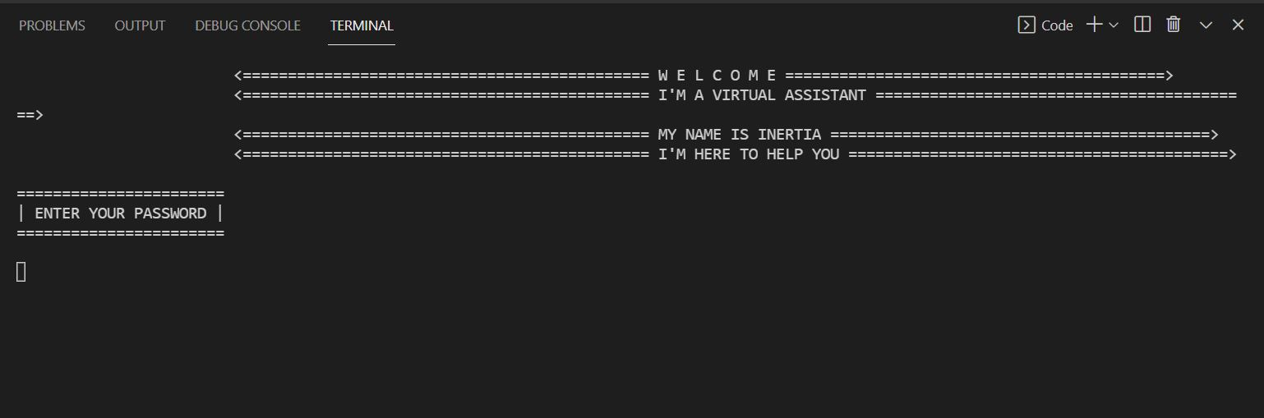

2

**2.Greeting the user:**

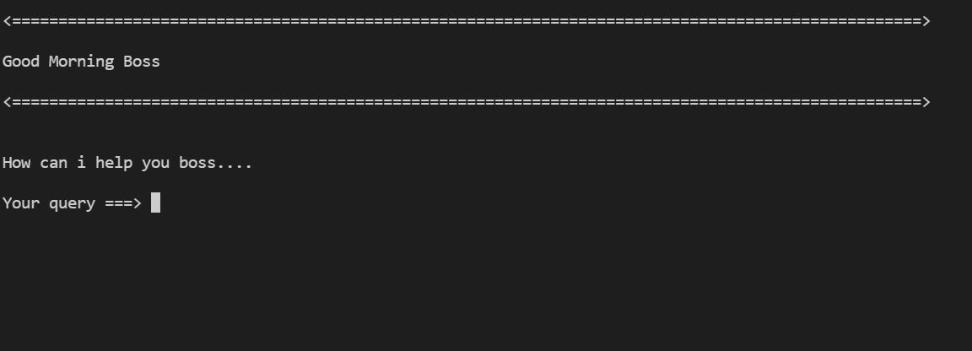

* 1. **Showing Date and Time**

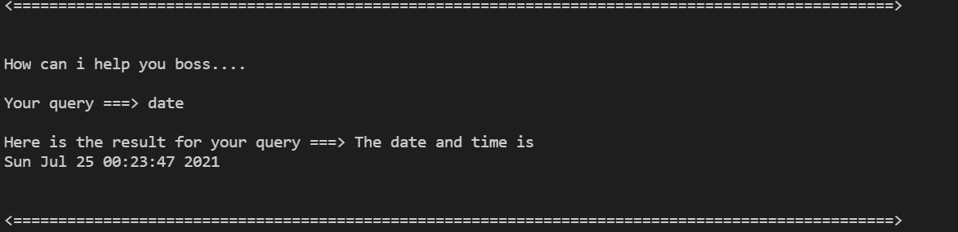

* 1. **User asking for opening Notepad**

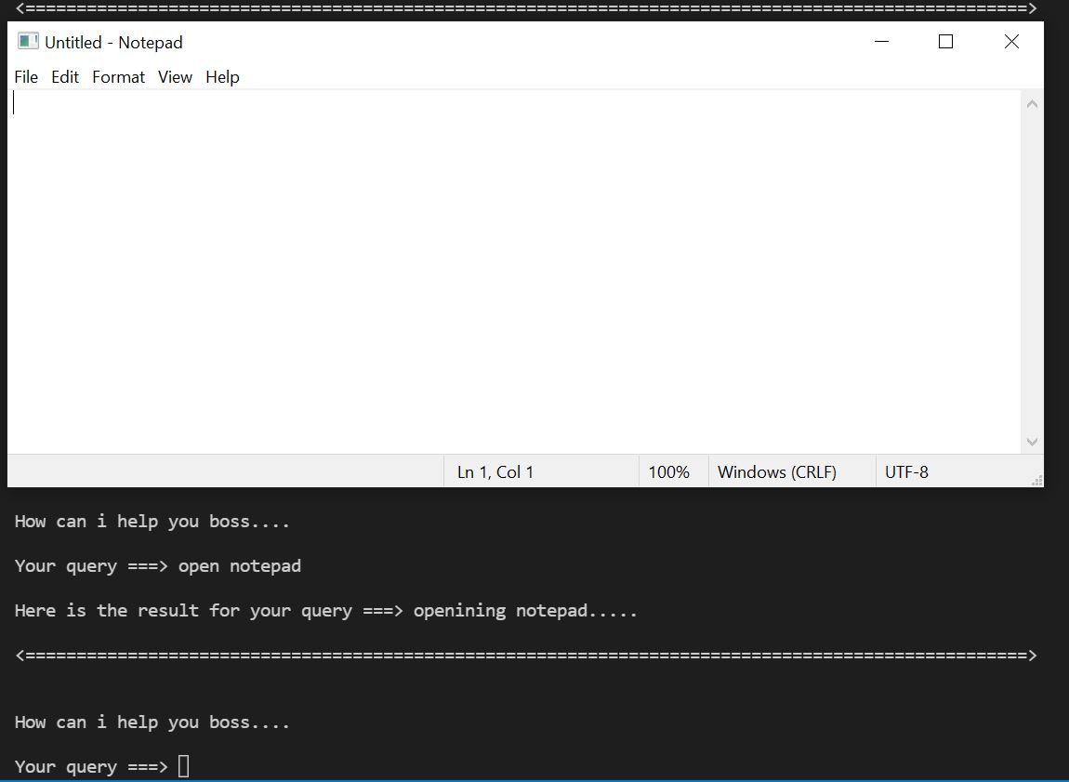

3

* 1. **Opening hackerrank:**

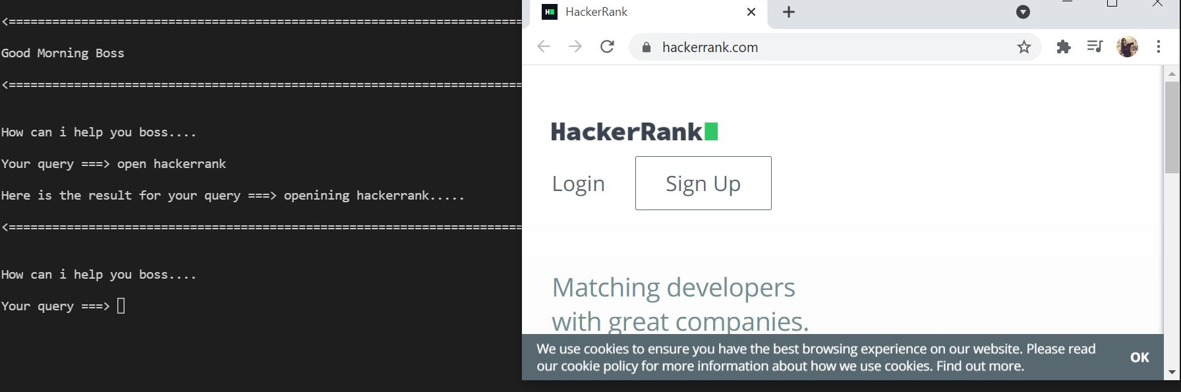

* 1. **Opening github:**

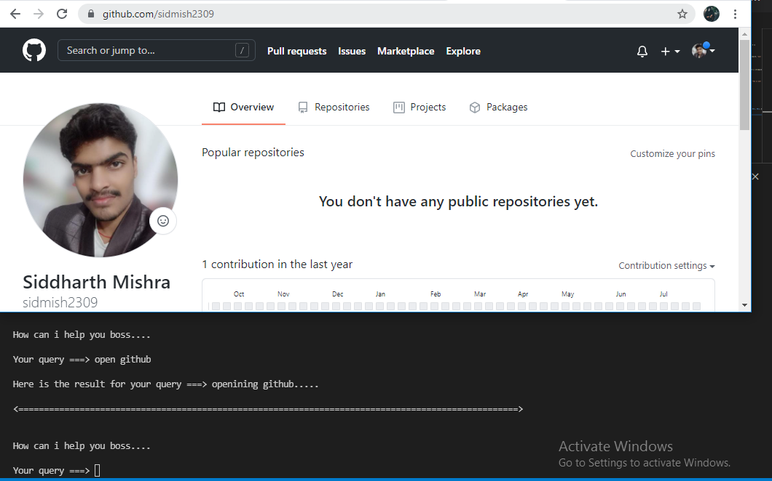

* 1. **Asking for input again if unable to recognize:**

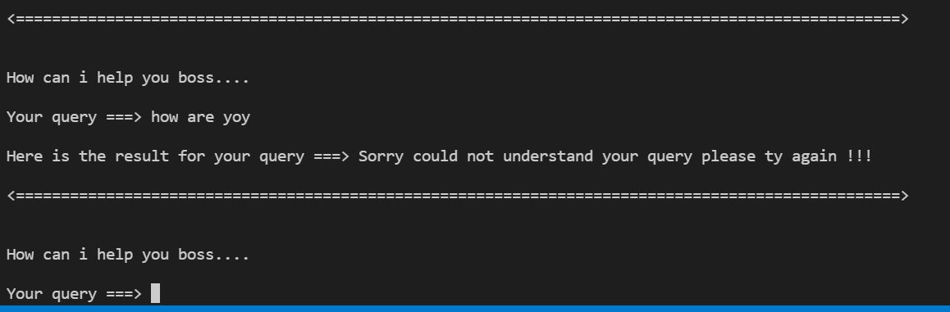

**4**

# PROBLEMFORMULATION

# Now-a-days, people are inventing many technologies to leisure human efforts.

# As we all know,2019 was a difficult year C:\Users\vishu dhamija\Desktop\table 2.pngfor all of us and in such kind of

# Pandemic situation, when we all should care about social distancing norms. So this is best

# time for us to shift towards technologies in different fields. Everybody is preferring work from home in this time.

# But according to recent surveys, it has been concluded that people are still not properly using these technologies.

# We already have multiple virtual assistants. But we hardly use it. There are number of people who have issues in voice recognition. These systems can understand English phrases but they fail to recognize in our accent. Our way of pronunciation is way distinct from theirs. Also, they are easy to use on mobile devices than desktop systems. There is need of a virtual assistant that can understand English in Indian accent and work on desktop system.

When a virtual assistant is not able to answer questions accurately, it’s because it lacks the proper context or doesn’t understand the intent of the question. Its ability to answer questions relevantly only happens with rigorous optimization, involving both humans and machine learning. Continuously ensuring solid quality control strategies will also help manage the risk of the virtual assistant learning undesired bad behaviour. They require large amount of information to be fed in order for it to work efficiently.

Virtual assistant should be able to model complex task dependencies and use these models to recommend optimized plans for the user. It needs to be tested for finding optimum paths when a task has multiple sub-tasks and each sub-task can have its own sub-tasks. In such a case there can be multiple solutions to paths, and the it should be able to consider user preferences, other active tasks, priorities in order to recommend a particular plan.

**5**

# RESEARCHOBJECTIVES

The proposed research is aimed to carry out work leading to the development of an approach for vulnerable code clone detection. The proposed aim will be achieved by dividing the work into following objectives:

* To understand and explore various types of software vulnerabilities existing in open source software.
* To design and develop the technique for virtual assistant.
* To verify and validate the proposed system.
* To study and find those mundane tasks that are time consuming and repetitive in nature.
* To analyze various types of requirements useful for writing virtual assistant code.
* To establish an environment by virtue of which users can enjoy while using this virtual assistant.
* To provide users flexibility to contract for just the services they need, and can help them free up the valuable hours.

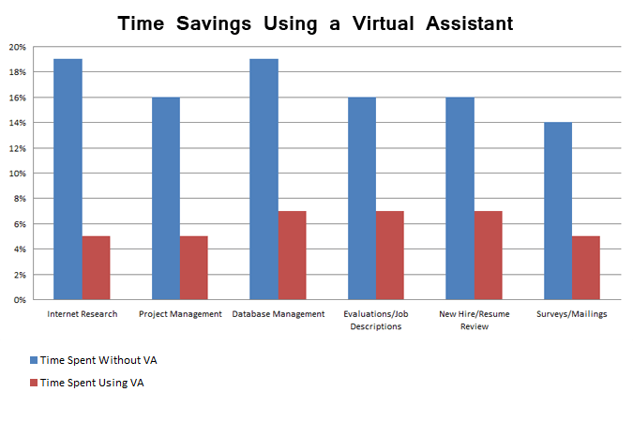

# 6

# METHODOLOGY

The following methodology will be followed to achieve the objectives defined for proposed research work:

* Comprehensive analysis of Virtual desktop assistant and taking idea of basic requirements for its implementation.
* Looking for the best IDE which can understand the code much better and can provide features such as build automation, code linting, testing and debugging.
* A specific database will be created, which corresponds to the C/C++ open source projects that enables automation of vulnerability management, security management, and compliance.
* Looking for some of the open source softwares so that the assistant can get a voice for responding to the user’s query.
* An approach will be involved for introducing Espeak, which is a open source software for giving text to speak(TTS) command in the program .
* Writing code with suitable functions and commands for making such a assistant that will respond the user’s demand accurately.
* Debugging of the code done and it give us knowledge about the various features of virtual assistants.
* Contrast the new implemented approach with already existing approaches.

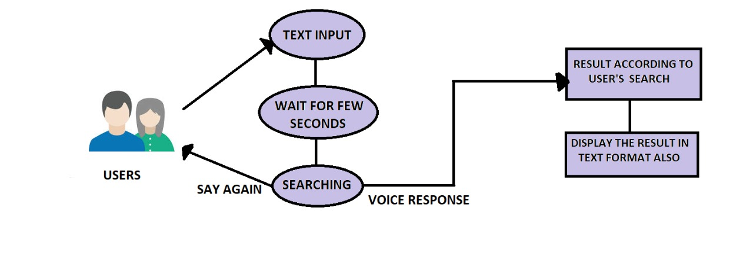

**7**

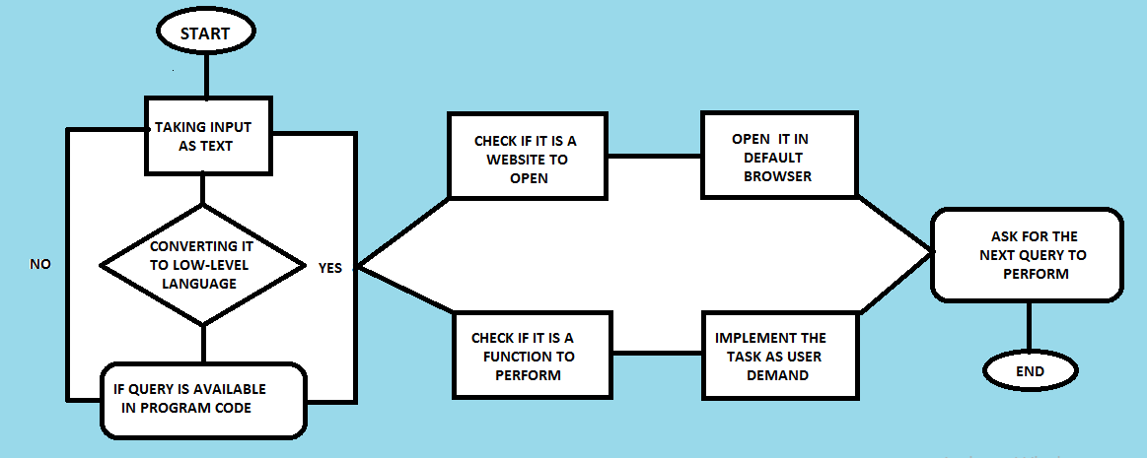

**A basic demonstration of the virtual assistant**

**8**

**RESULTS AND DISCUSSION**

* Voice Controlled devices uses Natural Language Processing to process the text/speak command from the user, understand it and then respond it with a process.
* This type of devices can also be designed for visually impaired people and can give them a better understanding.
* Through this virtual assistant, we can automate various services using a single line command and it is easy to operate.
* It is very effective to organize our own schedule in the laptop/PC as we can use notification commands in it.
* The entire learning outcome of this project has proved to be immensely beneficial for our future application development.
* This type of assistants can also be designed to accept commands in bilingual language and respond back with the same language queried by the user.
* The accuracy of these assistants is increasing exponentially in the last decade, and can be more useful if we use machine learning, categorizing queries in particular result sets and use them further.
* The future scope for this project reflects a growing market and attraction for the users.
* I face some of the difficulties while writing the code:

1. About how to give assistant a voice command in C++.
2. In the debugging of code also, because it is a single time command process.

**9**

# REFERENCES

# <https://www.google.com/search?q=virtual+assistant+images&sxsrf=ALeKk03VHh6BgA02pUx6UQpLMd0dXlXXEQ:1627050241336&tbm=isch&source=iu&ictx=1&fir=n2-ctpgKH2CFsM%252CvTSMGbwcuzs3CM%252C_&vet=1&usg=AI4_-kR-Sd-uFFheiiO1O6jOsYw1VBbUg&sa=X&ved=2ahUKEwjl46m9svnxAhX5wjgGHcfFCeAQ9QF6BAgEEAE&biw=1280&bih=609#imgrc=n2-ctpgKH2CFsM>

# <https://library.concordia.ca/help/writing/literature-review.php>

# <https://www.google.com/search?q=list+of+figures+in+report&oq=list+of+figures+&aqs=chrome.1.69i57j0l9.5552j0j15&sourceid=chrome&ie=UTF-8>

# <https://en.wikipedia.org/wiki/Virtual_assistant>

# <https://www.lifewire.com/virtual-assistants-4138533>

# <https://www.google.com/search?q=virtual+assistant+&tbm=isch&ved=2ahUKEwisi-vJt_nxAhXMEXIKHZVDnMQ2cCegQIABAA&oq=virtual+assistant+&gs_lcp=CgNpbWcQAzIECCMQJzIECCMQJzICCAAyAggAMgIIADICCAAyAggAMgIIADICCAAyAggAUIsMWNQWYLYqaABwAHgAgAG8AYgB_AuSAQMwLjmYAQCgAQGqAQtnd3Mtd2l6LWltZ8ABAQ&sclient=img&ei=Wdb6YOz6LMyjyAOfq7qYBw&bih=609&biw=1280>

# <https://www.abetteranswer.com/blog/what-is-a-virtual-assistant-how-one-can-benefit-you>

# <https://www.practiceofthepractice.com/4-benefits-of-virtual-assistants/>

# <https://www.youtube.com/watch?v=MNjAvPdt0ZQ>

# <https://www.daniweb.com/programming/software-development/threads/469898/personal-assistant>

# <https://www.scribbr.com/dissertation/literature-review/>

# <https://www.google.com/search?q=virtual+assistant+report&tbm=isch&ved=2ahUKEwja_ZTNt_nxAhX6KLcAHRWZCV8Q2cCegQIABAA&oq=virtual+assistant+rep&gs_lcp=CgNpbWcQARgAMgQIABAYOgQIIxAnOgQIABBDOgIIAFC3IVjWQWC8TmgAcAB4AIABvAGIAbcFkgEDMC40mAEAoAEBqgELZ3dzLXdpei1pbWfAAQE&sclient=img&ei=YNb6YNrNK_rR3LUPlbKm-AU&bih=609&biw=1280#imgrc=qucL9eqzDEtG6M>

**10**